 | Travel Request
APPLICANT: |  | Jihane Najar
PROJECT/CUSTOMER: |  | CoEvolution
REASON: |  | Plenary Meeting
DESTINATION: |  | Graz, Austria
DATES of the event: |  | 25-26 June 2025
FLIGHT OPTIONS  (flex tickets preferable – not business class)  (departure and arrival dates and  estimated cost): |  | Frankfurt to Graz: Tuesday, 24 June 2025  Graz to Frankfurt: Friday, 27 June 2025  ≈ 435,14 Euro + Assurance  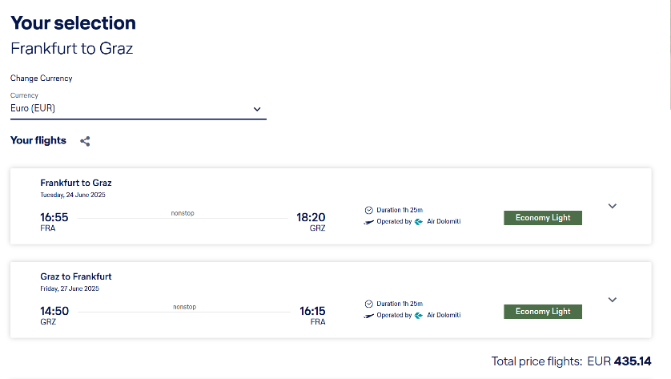
HOTEL OPTIONS (estimated cost/night): |  | EKONO By Leva Hotel Strasser  Per night ≈ 121,66 Euro  Total ≈ 365 Euro
OVERNIGHTS (number): |  | 3
TOTAL REQUESTED ADVANCE PAYMENT  (The above estimated costs in €) |  | 984,52 Euro
COMMENTS (e.g. train tickets cost, cost for the participation in the event, registration fees etc): |  | Train ticket: 100,38 Euro

